Performance Project Report

Airport Simulation

_________________________________

By:

Zahraa Hossam – 4558

George Amgad – 5002

**Assumptions:**

Observation time = 500 minutes

Number of servers = 3

Service time of process A = 2+

Service time of process B1 = 6+

Service time of process B2 = 4+

Service time of process B3 = 4+

Service time of process D = 10+

Arrival rate = 0.1 passengers/second

Service rate = 0.5 jobs/second

A passenger cannot be precheck and no bag

**Description:**

**Performance metrics:**

Performance metrics: Avg waiting time: **45.35**, Avg service time: **28.86**, Avg response time: **74.21**

Completed **51** jobs, 0 with no bags and 0 precheck

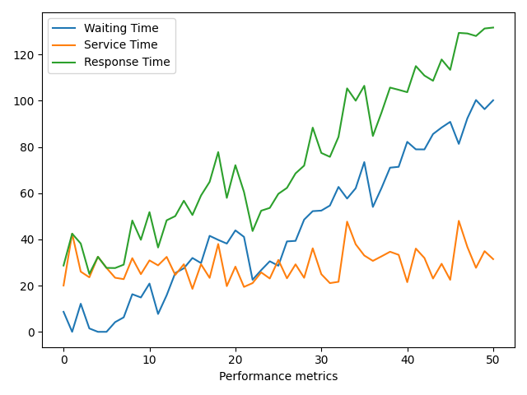

**Observation:**

1. **Improvements**
   1. **45% of passengers are members of the pre-check program.**  
      Performance metrics: Avg waiting time: **19.89**, Avg service time: **27.92**,   
      Avg response time: **47.81**

Completed **50** jobs, 0 with no bags and **26** precheck

Total Number of Passengers = 54 (completed jobs + uncompleted jobs)

Total Passengers with no baggage = 0

Total Pre check program passengers **27** (completed jobs + uncompleted jobs)

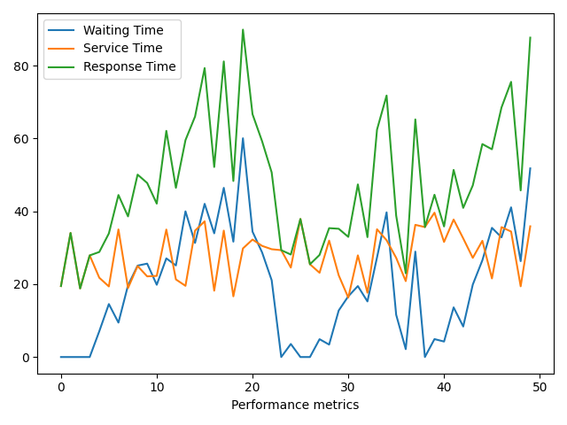

Observation:

* 1. A small number of passengers don’t have baggage

Performance metrics: Avg waiting time: **4.22**, Avg service time: **23.83**,   
Avg response time: **28.05**

Completed **44** jobs, **11** with no bags and 0 precheck

Total Number of Passengers = **46** (completed jobs + uncompleted jobs)

Total Passengers with no baggage = **12** (completed jobs + uncompleted jobs)

Total Pre check program passengers 0

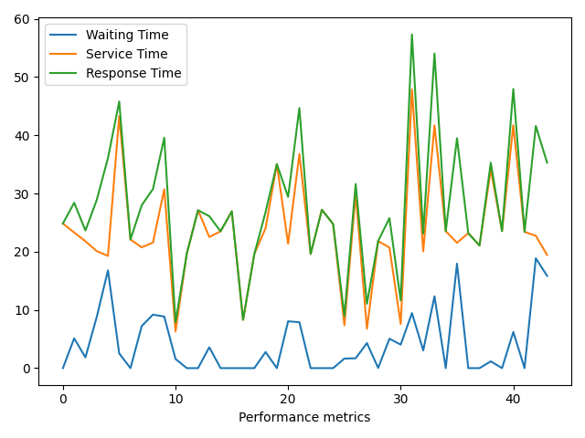

**Enabling both a and b**

Performance metrics: Avg TW: **6.73**, Avg TS: **24.31**, Avg response time: **31.04**

Completed **54** jobs, **16** with no bags and **21** precheck

Total Number of Passengers = **57**

Total Passengers with no baggage = **16**

Total Pre check program passengers **23**

